**Liberation: Union Organization System**

Contents

Project Summary 2

Key Features 3

Project Description 4

**Chapter One: Secure Sensitive Information Systems** 6

SQL Database Design – SSI & SCI 6

Domain Class Diagram 7

System Class Model 8

Use Case Model: Workplace Management 9

Creating a Workplace 10

Modifying a Workplace 11

Manage Workplace Data 12

Use Case Model: Managing Union Card Data 13

Signing a Union Card 14

Deleting a Union Card 15

Accessing a Union Card 16

Use Case Model: User Management 17

Add a New Organizer 18

Removing a User 19

Creating an Account 20

Project Summary

Liberation is a comprehensive organization system tailored for union organizers, designed to revolutionize the way campaigns are managed. It centralizes data, streamlines access to information, and modernizes union cards, providing a secure and efficient platform for campaign organization. With Liberation, organizers, staff, and workers can collaborate seamlessly, enhancing campaign effectiveness and information dissemination.

From robust security measures that protect sensitive information to the ability for staff to manage multiple workplaces, Liberation offers a suite of features that cater to the unique needs of union organizations. Admins can oversee all union activities, staff can upload training videos and monitor support levels, and organizers can manage workplaces with ease.

Liberation serves as a central hub for workers, providing them with access to training, a platform to ask questions, and a secure method to sign union cards. By transforming the way union campaigns are organized, Liberation not only benefits the users but also empowers organizations, fostering a more effective and secure environment for union organizing.

Key Features

**Safety Critical Information (SCI) Protection**

The system provides end-to-end encryption for the transmission of data and stores all SCI in encrypted formats, protecting information that could lead to the identification of workplace organization or any worker in the system.

**Data Management**

Data management is a crucial aspect of union organization. It’s essential to have attention focused on the areas that need the most across the country. With Liberation, you can access well-organized data and receive critical alerts from organizers throughout the campaign, ensuring you’re always informed and can respond promptly.

**Union Card Management**

Traditional methods of signing union cards can expose organizers to vulnerabilities, especially when physical cards are passed around and can be observed by management. Liberation mitigates this risk by digitizing the process. Workers can securely sign union cards and access training, reducing exposure and enhancing security.

**Training Management**

Liberation provides a comprehensive platform for managing member training. Training can be restricted to specific regions and phases of organization, ensuring relevance and effectiveness. Key concepts such as Weingarten Rights, FMLA, bargaining, ULP processes, Cemex Bargaining Orders, and failed votes can be covered, providing a thorough understanding of important topics.

**Announcements**

Keep all workers in the loop with the announcement feature. Whether it’s celebrating union victories or sharing important news, Liberation ensures that your message reaches all workers who use the app. This feature fosters a sense of community and keeps everyone updated on the latest developments.

Project Description

**Workplace Management System (WMS)**

Organizers, Staff, and Administration access the WMS to modify and access workplace information. WMS is used to create accounts for workers, modify worker information, modify workplace information, and to disseminate Safety Critical Information (SCI) through notifications.

**Worker Portal (WP)**

The worker portal is used by workers to access information that does not qualify as Safety Critical Information (non-SCI), to sign union cards, access training videos, and to ask organizers questions.

**The Administration Role**

The role of an Administrator is to manage staff and view organizational information for better informed resource allocation, and to manage organization-wide information dissemination utilizing notifications. An administrator can add and remove staff and other administrators, view information from every union drive registered to their organization and create and manage staff jurisdictions.

The home page of the WMS shows information, summarized with full in-depth profile information on each jurisdictional campaign and workplace information. Training material to be approved is on the WMS Administrators screen, to be approved by the criteria established by the organization.

**The Staff Role**

The role of Staff is to manage multiple workplaces under their jurisdiction utilizing the WMS, manage the training of their jurisdictions. Staff can utilize the WMS to add and remove Organizers from the system, as well as generating and managing workplaces. Staff can upload training videos with administrator approval as well as restrict videos to geographical areas to help train workers in area labor laws and utilize announcements for important information. Staff can send information via notifications to WP and WMS by designating information as SCI or non-SCI, notifications are by default SCI.

The home page of a staff members WMS summarizes important information, including upcoming election dates, the top five lowest and highest percentage of “Voting Yes” workplaces, worker questions, and important notifications such as when support falls below 50% or when there are no more organizers in the store.

**The Organizer Role**

The role of an organizer is to manage a workplace. Organizers can access the WMS to add and remove workers and manage worker information, this will include important information such as worker data, contact information, support levels, and notes.

The homepage of the WMS for an organizer includes summary information on the workforce, election information and workplace notifications, as well as worker information.

**The Worker Role**

Liberation will be a central hub for workers to access important information. The worker role is restricted from accessing the WMS for informational security and instead accessing the WP for training videos, to ask organizers questions, and to sign union cards. No SCI is disseminated over the WP.

**Security Measures**

It is imperative to recognize that highly sensitive information is handled in union organizations. All data in our Secure Sensitive Information (SSI) systems are encrypted in storage and transmitted over secured connections. The invite only system to the WMS and the need-to-know information restrictions reduce access to the system and to SSI from bad faith actors. To create an account, a user of the WMS will enter basic contact information and the WMS will email the temporary password to both the adder’s email and the worker’s email. By limiting accounts to those created by trusted Organizers and Staff, access to the system is limited to bad actors.

The WMS is secured by the session preventing prolonged unauthorized access to Secured Sensitive Information. The WMS will require 2FA verification to start a session. Sessions timeout after 15 minutes prompting a user to extend the time by another 15 minutes by logging in, keeping 2FA status if extended within 2 minutes.

Account Password requirements are as follows with 16 characters, numbers, capitalization, and special characters, urging users to use sentences and not to write down the passwords. After a failed password entry, WMS users will be prompted to complete a captcha before another attempt. Accounts and IP addresses will have a maximum number of attempts before being locked out. After 5 failed attempts in a row the account will be locked out and require Liberation Staff to reset the password.

SCI, if leaked, can be detrimental to union organization. With access to SCI then retaliation can be highly targeted, and information sold for a high price. It is imperative that Information be protected in transit and at rest, Liberation provides end to end encryption for the transmission of data and stores all SCI in encrypted formats. Data classified as SCI is any information that can lead to the identification of workplace organization, or any worker in the system; this includes workplace meta-data, worker contact information, union cards, and workplace notifications.

# **Chapter One: Secure Sensitive Information Systems**

## SQL Database Design – SSI & SCI

* “e” Denotes SCI

## Domain Class Diagram

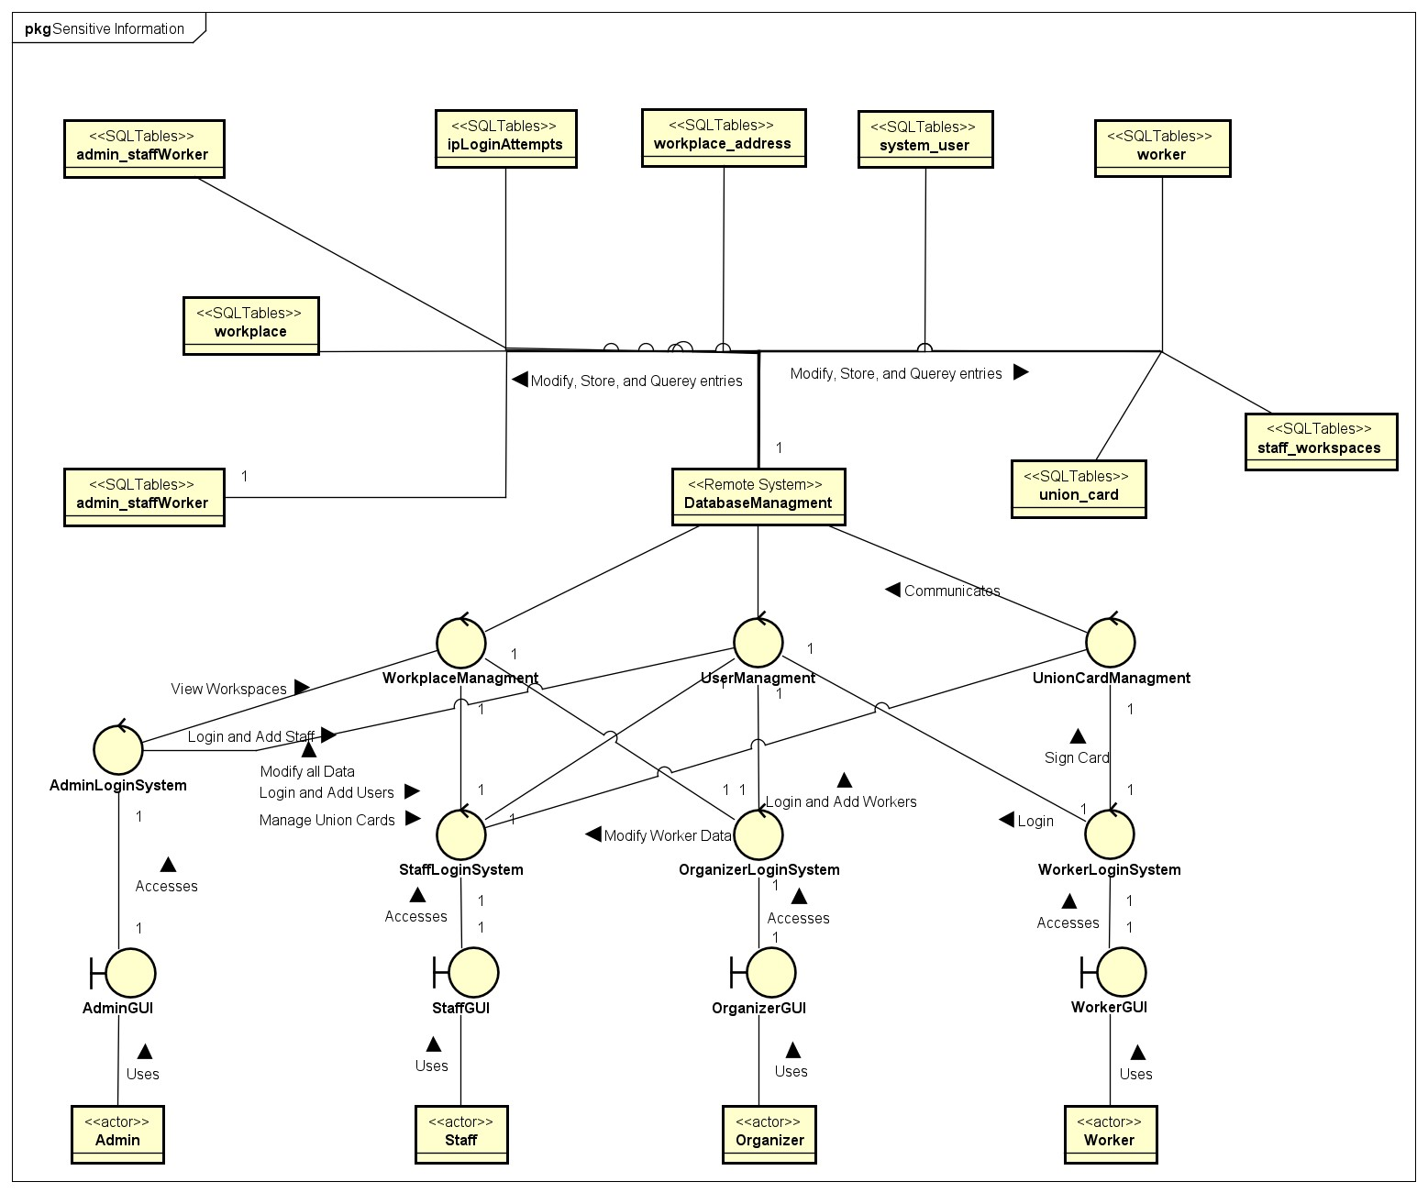

## System Class Model

## Use Case Model: Workplace Management System

### Creating a Workplace

### Modifying a Workplace

### Manage Workplace Data

## Use Case Model: Managing Union Card Data

### Signing a Union Card

### Deleting a Union Card

### Accessing a Union Card

## Use Case Model: User Management

### Add a New Organizer

### Removing a User

### Creating an Account

